# LoanWise: The Future of Loan Eligibility Verification

Submitted by

Student Name: Md. Shakil Sheikh ID No: 213-0001-203

A Project Submitted in Partial Fulfillment of the Requirements for the Degree of Bachelor of Science in Computer Science and Engineering

Supervisor: Name of your Supervisor, Designation



Atish Dipankar University Of Science And Technology April, 2024

**DECLARATION**

We hereby declare that this submission is our own work and to the best of our knowledge it contains no materials which are exactly same which were previously published anywhere in print or soft.

Date Name of the student

Roll:212-XXXX-XXXX

**CERTIFICATE**

B.Sc. Project entitled: “

under my supervision, meets acceptable presentation that is standard and can be submitted for evaluation to the department of Computer Science and Engineering in partial fulfillment of the requirement for the degree of Bachelor of Science (B.Sc.) in Computer Science and Engineering.

Date: Name of supervisor

Position of supervisor Department of CSE

Atish Dipankar University of Science and Technology

**ACKNOWLEDGEMENTS**

We feel pleased to have the opportunity of expressing our heartfelt thanks and gratitude to those who all rendered their cooperation in making this report. This section is intended to show recognition and appreciation to those people who helped the candidate (s) in some way through the project and its report.

**ABSTRACT**

This is a brief summary intended to help the reader quickly ascertain the purpose, argument and finding of the project and its report. This should not be more than one page. It is noted that the entire project report should be written in times roman font with size 12pt, and 1.5 lines spacing for the paragraph and justified except figure and table caption, reference and appendix section. The page margin should be left:

* 1. inch, right, top bottom: 1 inch. All captions of the figure with number should be bold, centered, and font size 10pt whereas for table it should be left aligned. For details, refer to the list of figures/tables section. You must start a new section in a new page. For example, each chapter/topic should start in a new page. Abstract should be of one paragraph.

**Keywords:** State 3 to 4 keywords( main terms of your project)

**LIST OF FIGURES**

**Figure**

* 1. Robot kit . . . . . . . . . . . . . . . . . . . . . . . . . . . . . . . . 3
  2. Vasteras Giraff . . . . . . . . . . . . . . . . . . . . . . . . . . . . . 3
  3. Robot kit . . . . . . . . . . . . . . . . . . . . . . . . . . . . . . . . 6

**LIST OF TABLES**

**Table**

* 1. Example of a table . . . . . . . . . . . . . . . . . . . . . . . . . . . 5

**LIST OF ABBREVIATIONS**

**CAD/CAM** Deep Neural Network

**RNN** Recurrent Neural Network

**TABLE OF CONTENTS**

**DECLARATION***. . . . . . . . . . . . . . . . . . . . . . . . . . . . . . . . .* ii

### CERTIFICATE iii

**ACKNOWLEDGEMENTS**iv

|  |  |
| --- | --- |
| **ABSTRACT***. . . . . . . . . . . . . . . . . . . . . . . . . . . . . . . . . . .* | v |
| **LIST OF FIGURES***. . . . . . . . . . . . . . . . . . . . . . . . . . . . . . .* | vi |
| **LIST OF TABLES***. . . . . . . . . . . . . . . . . . . . . . . . . . . . . . . .* | vii |
| **LIST OF ABBREVIATIONS***. . . . . . . . . . . . . . . . . . . . . . . . .* | viii |
| **CHAPTER** |  |
| **I. INTRODUCTION**. . . . . . . . . . . . . . . . . . . . . . . . . . | 1 |
| 1.1 Overview . . . . . . . . . . . . . . . . . . . . . . . . . . . . . | 1 |
| 1.2 Problem Statement /Motivation (Sample) . . . . . . . . . . . | 1 |
| 1.3 Contribution (Sample) . . . . . . . . . . . . . . . . . . . . . | 2 |
| 1.4 Organization of the Project (Sample) . . . . . . . . . . . . . | 2 |
| 1.5 Research Outline . . . . . . . . . . . . . . . . . . . . . . . . . | 3 |
| **II. BACKGROUND STUDY**. . . . . . . . . . . . . . . . . . . . . . | 4 |
| 2.1 Conceptual Study . . . . . . . . . . . . . . . . . . . . . . . . | 4 |
| 2.2 Related Works . . . . . . . . . . . . . . . . . . . . . . . . . . | 4 |
| 2.2.1 Motivating papers . . . . . . . . . . . . . . . . . . | 4 |
| **III. METHODOLOGY**. . . . . . . . . . . . . . . . . . . . . . . . . . | 6 |
| 3.1 Methodology . . . . . . . . . . . . . . . . . . . . . . . . . . . | 6 |
| 3.2 Design & Development . . . . . . . . . . . . . . . . . . . . . | 6 |
| **IV. PERFORMANCE ANALYSIS**. . . . . . . . . . . . . . . . . . . | 7 |

* 1. Result & Discussion . . . . . . . . . . . . . . . . . . . . . . . 7
  2. Comparative Study . . . . . . . . . . . . . . . . . . . . . . . 7

**V. CONCLUSION**. . . . . . . . . . . . . . . . . . . . . . . . . . . . 8

5.1 Conclusion & Future work . . . . . . . . . . . . . . . . . . . 8

**VI. Performance Analysis**. . . . . . . . . . . . . . . . . . . . . . . . 9

* 1. Fuzzification . . . . . . . . . . . . . . . . . . . . . . . . . . . 9
     1. Fuzzification Method: . . . . . . . . . . . . . . . . . 9

**Bibliography**10

**CHAPTER I**

# INTRODUCTION

The first chapter should introduce the subject of the project, its objectives and explain the structure of the dissertation to the reader. You should also include lit- erature review (the published works related to your project) as a subsection in this chapter.

## Overview

Robot is an electro-mechanical device which can be programmed to perform some task of manipulation or locomotion under automatic control. Programs can differ in their nature [1]. The fact that a robot can be reprogrammed is important; it is definitely a characteristic of robots. To perform any useful task the robot must interface with the environment, which may comprise feeding devices, other robots, and most importantly people. It is the fifth most-spoken native language and the seventh most spoken language by total number of speakers in the world[2].In last few years researchers have got interests in this matter.But as spoken before the number of quality researches are few on Bangla speech recognition.That is why we have made our mind to work on this topic.Though it sounds like a short task, it is quite diﬀicult to accomplish as speech contains multiple characteristics.

## Problem Statement /Motivation (Sample)

Mobile robots may be classified by

* + 1. The environment in which they travel
       1. Land or home robots are usually referred to as Unmanned Ground Vehicles (UGVs). They are most commonly wheeled or tracked, but also include

legged robots with two or more legs (humanoid, or resembling animals or insects).

* + - 1. Delivery & Transportation robots can move materials and supplies through a work environment.
      2. Aerial robots are usually referred to as Unmanned Aerial Vehicles (UAVs)
      3. Underwater robots are usually called autonomous underwater vehicles (AUVs).
      4. Polar robots, designed to navigate icy, crevasse filled environments.
    1. The device they use to move, mainly (Sample)
       1. Legged robot : human-like legs (i.e. an android) or animal-like legs.
       2. Wheeled robot.
       3. Tracks

## Contribution (Sample)

i In terms of color of line and background

I Following black line on white background

II Following white line on black background ii In terms of dimensions of line

I Two dimensional

II Three dimensional

## Organization of the Project (Sample)

Technological advancement in the field of science has paved the way to the in- vention of sophisticated machines, which could assist us and simplify our work. One such valuable invention of humankind is robots. By flipping through the pages of history, it is studied that people in the ancient Greece and Egypt started using the raw form of robots, for accomplishing various kinds of works. With the passing time, robotics saw further developments. The design of robots became more and more sophisticated, with the increase in the capacity of the machines to do work. In this article, we have gone back to the history and traced some interesting information on the background and origin of robotics - the science and technology of robots.

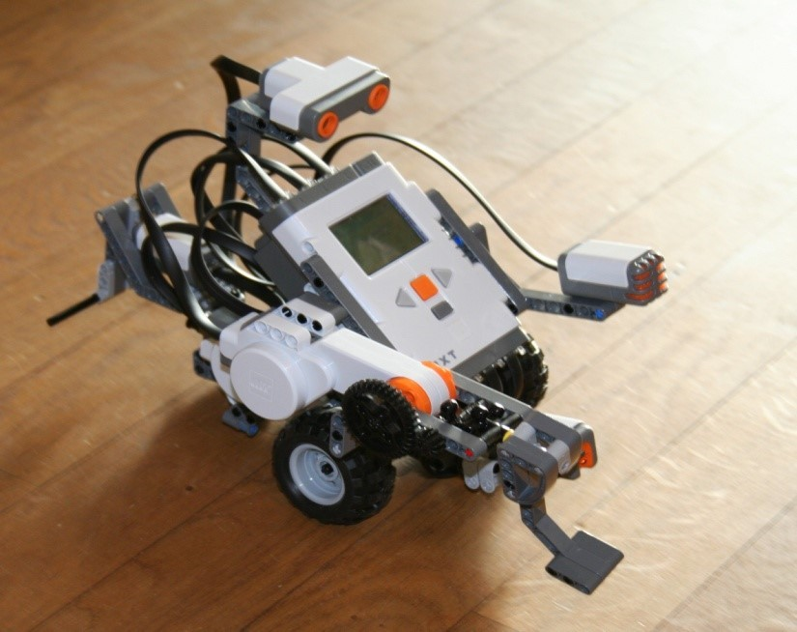

Fig 1.1: Robot kit

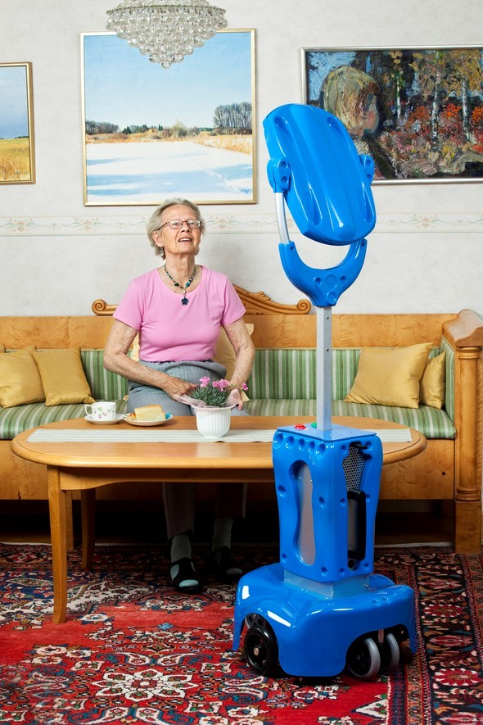

Fig 1.2: Vasteras Giraff

## Research Outline

Rest of the report is structured as follows: In **Chapter** **II**a theoretical study and literature study on related work is given in this chapter. **Chapter** **III**intro- duces system model including system overview, different system models of working procedure of entire system,flow charts and an experimental time chart.In **Chapter** **IV**conclusion and future work are mentioned.

**CHAPTER II**

# BACKGROUND STUDY

## Conceptual Study

Robot is an electro-mechanical device which can be programmed to perform some task of manipulation or locomotion under automatic control. Programs can differ in their nature [1]. The fact that a robot can be reprogrammed is important; it is defi- nitely a characteristic of robots. To perform any useful task the robot must interface with the environment, which may comprise feeding devices, other robots, and most importantly people. **This chapter should present a more detailed background to the problem and theories/components related to your project/intern. There will be a summary of Chapter-2.**

## Related Works

In this paper, the robots that have been used [3]. Equations: Equations should be given in a separate line. Number equations consecutively with equation numbers in parentheses flush with the right margin, as in 2.1.

In this paper [4], sentiment analysis techniques and methodologies have been discussed.

*y* = *mx* + *c* (2.1)

### Motivating papers

In the table 2.1, a summary of used parameters are given. We have gone through a paper named **Paper title**[1]– A new framework has been applied to construct

Table 2.1: Example of a table

|  |  |  |  |
| --- | --- | --- | --- |
| 2powerType size (pts) | Appearance | | |
| Regular | Bold | Italic |
| 1 | Abc | fg |  |
| 2 | Abc | gh |  |
| 3 | Abc | hk |  |
| 4 | Abc | uu |  |
| 5 | Abc | fd |  |
| 6 | Abc | ji |  |

a domain based continuous speech recognition system based on HMM model. To prepare text to speech corpus, training and integrating dataset with the system, their work has also extended to test the CSR in various environments in basic level. Comparing to research paper[5] their average accuracy rate was better which was around 71.58% for unknown speakers. A Thesis work known as **Bangla Speech to Text Conversion Using CMU Sphinx**[5] – A dataset has been constructed where 8 speakers recorded 101 words, among them for better accuracy 6 speakers recorded each word 3 times and other 2 speakers recorded each word one time. Also a word matching algorithm which is developed by the researchers,a Hidden Markov Model based acoustic model ,a n-gram method based language model has been constructed. In their proposed system, they generate a language dictionary using the CMUSphinx framework. After testing their system, for known speakers they got a accuracy around 78.57%. and for unknown speakers the accuracy was around 59.01%.

But limitations of this two papers[1][5]are similar. A speech recognition system at least needs 50 speakers to train a decoder where the number of speakers were deficient as well as the spoken words. So it is unknown, how the system will secure average success rate in case of large dataset and with massive speakers.

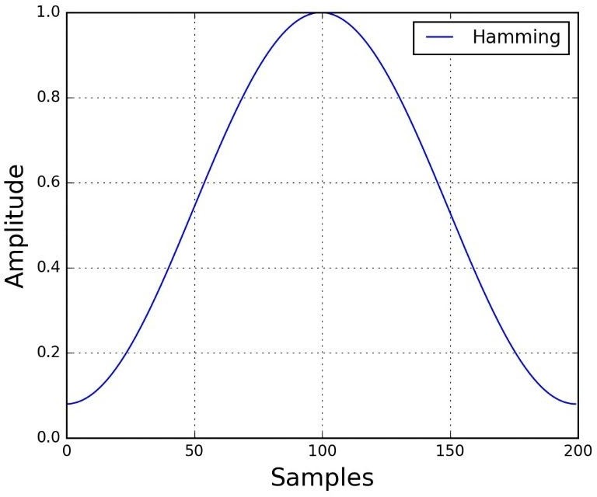

Fig 3.1: Robot kit

**CHAPTER III**

# METHODOLOGY

## Methodology

Robot is an electro-mechanical device which can be programmed to perform some task of manipulation or locomotion under automatic control. Programs can differ in their nature.

* 1. **Design & Development**

**CHAPTER IV**

# PERFORMANCE ANALYSIS

**Direction:** This chapter should present and discuss the results achieved once the proposed method is implemented. A format test plan must be introducing in the beginning of the chapter.

* 1. **Result & Discussion**
  2. **Comparative Study**

**CHAPTER V**

# CONCLUSION

**Direction:** It should contain the conclusions drawn following the project, com- parisons which may be made between this the existing work or practice and suggestion regarding the extension of continuation of the work.

* 1. **Conclusion & Future wor**

**Bibliography**

1. S. A. Chowdhury, “Implementation of speech recognition system for bangla,” 2010.
2. Z. Van Dijk, “Wikipedia and lesser-resourced languages,” *Language Problems and Language Planning*, vol. 33, no. 3, pp. 234–250, 2009.
3. A. Imario, D. W. Sudiharto, and E. Ariyanto, “The validated voice recognition measurement of several tribes in indonesia using easy vr 3.0. case study: The prototype of automated doors,” in *2017 International Seminar on Application for Technology of Information and Communication (iSemantic)*, pp. 132–136, IEEE, 2017.
4. W. Medhat, A. Hassan, and H. Korashy, “Sentiment analysis algorithms and applications: A survey,” *Ain Shams engineering journal*, vol. 5, no. 4, pp. 1093– 1113, 2014.
5. I. J. Bristy, N. I. Shakil, T. Musavee, and A. R. Choton, “Bangla speech to text conversion using cmu sphinx,” 2019.